1. IP: 192.168.1.182 Port: 1161

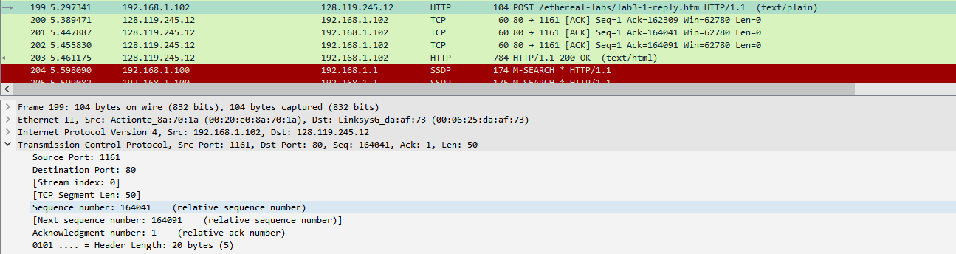

1. IP: 128.119.245.12 Port: 80

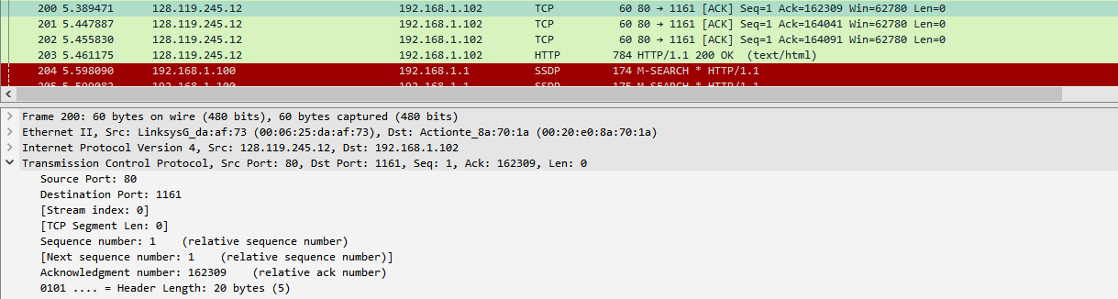

1. IP: 192.168.1.182 Port: 1161 (see figure 1 for reference)
2. The sequence number of the TCP SYN segment is 0 since it is used to emulate the TCP connection between the client computer and gaia.cs.umass.edu. Syn flag is set to 1 which indicates that this segment is a SYN segment.

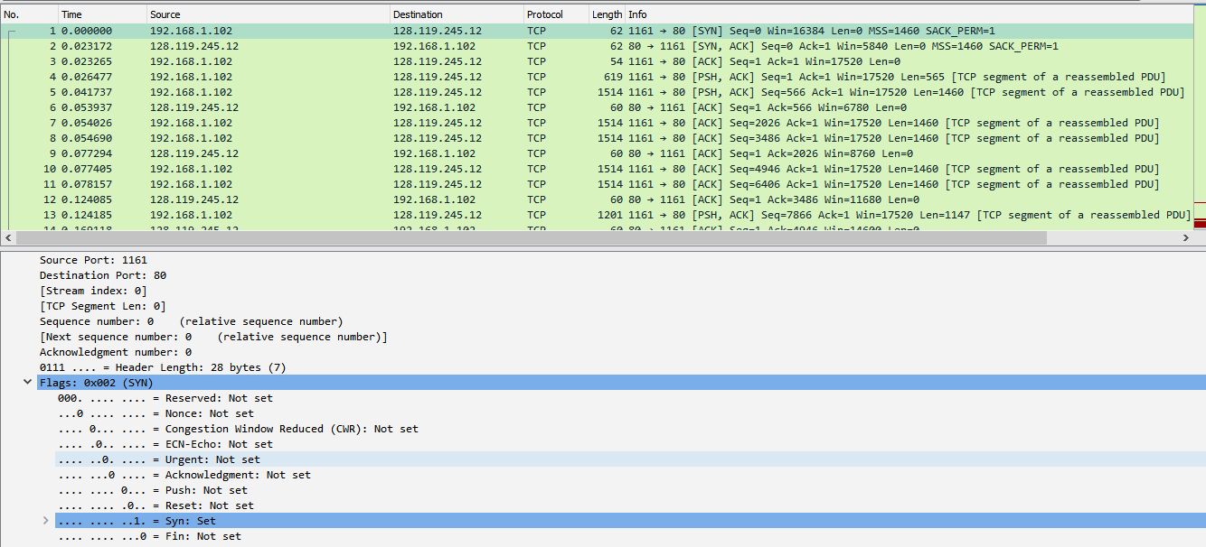

1. According to the figure below, the sequence number of the SYNACK segment sent by gaia.cs.umass.edu to the client computer in reply to the SYN is 0. The value of the acknowledgement field in the SYNACK segment is 1. The server adds 1 to the initial sequence number of SYN segment form the client computer. It will be identified as a SYNACK segment if both SYN flag and Acknowledgement are set to 1.

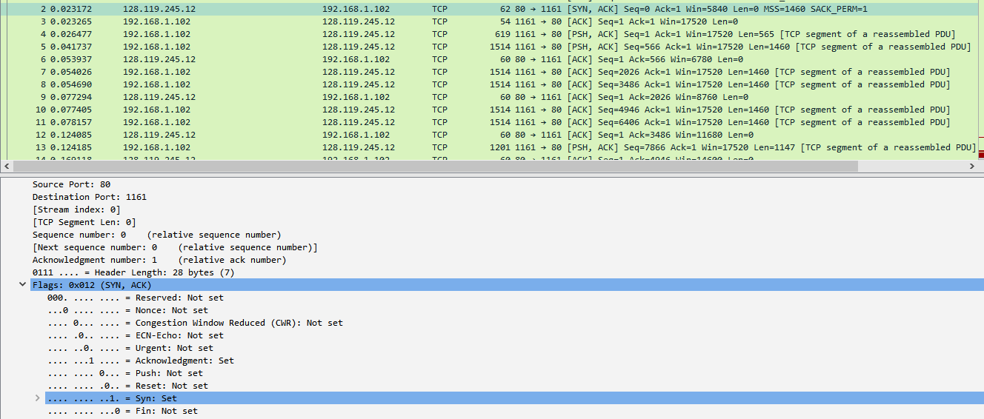

1. According to the figure, the segment no. 4 contains the HTTP POST command, the sequence number of this segment is 1.

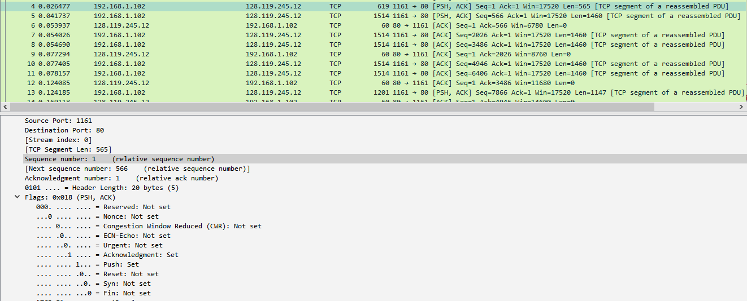

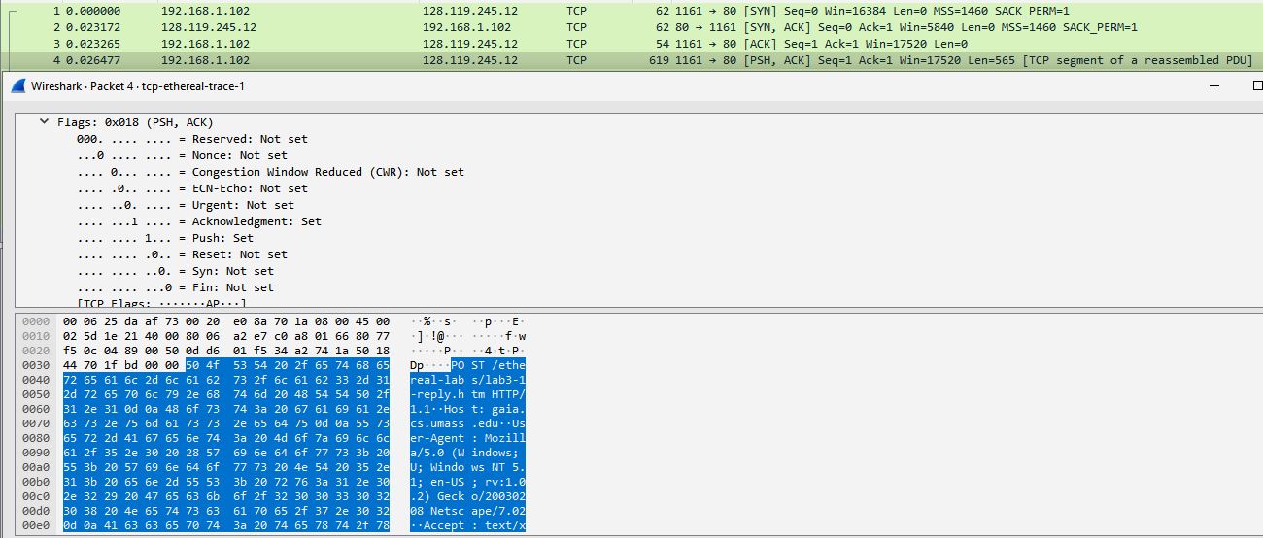

1. The figure above displays the sequence number of first six segments

For segment 4: sequence number: 1

For segment 5: sequence number: 566

For segment 7: sequence number: 2026

For segment 8: sequence number: 3486

For segment 10: sequence number: 4946

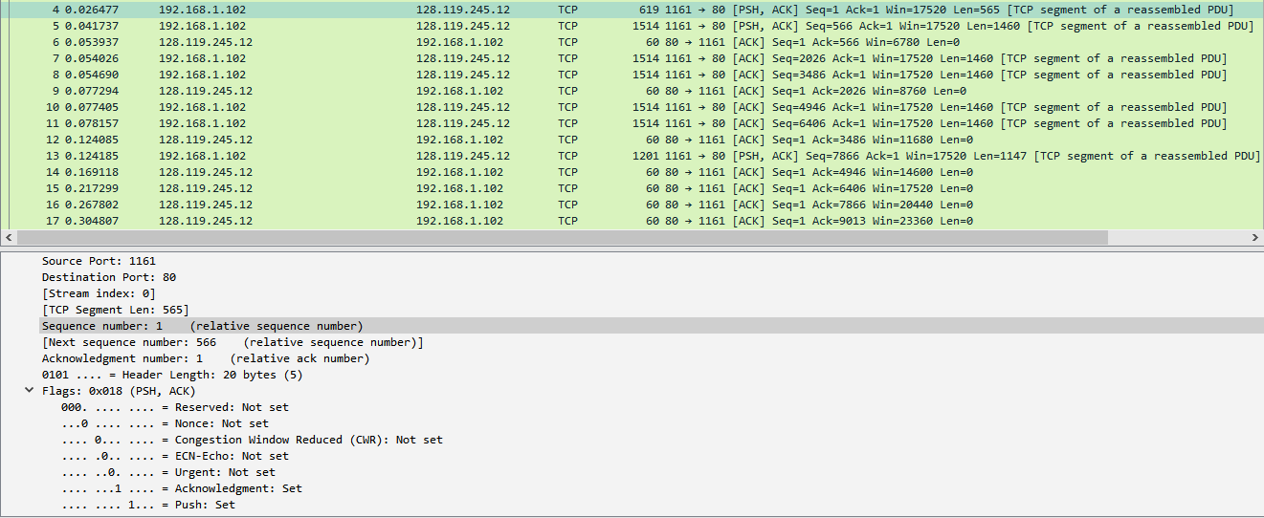

(No 4)

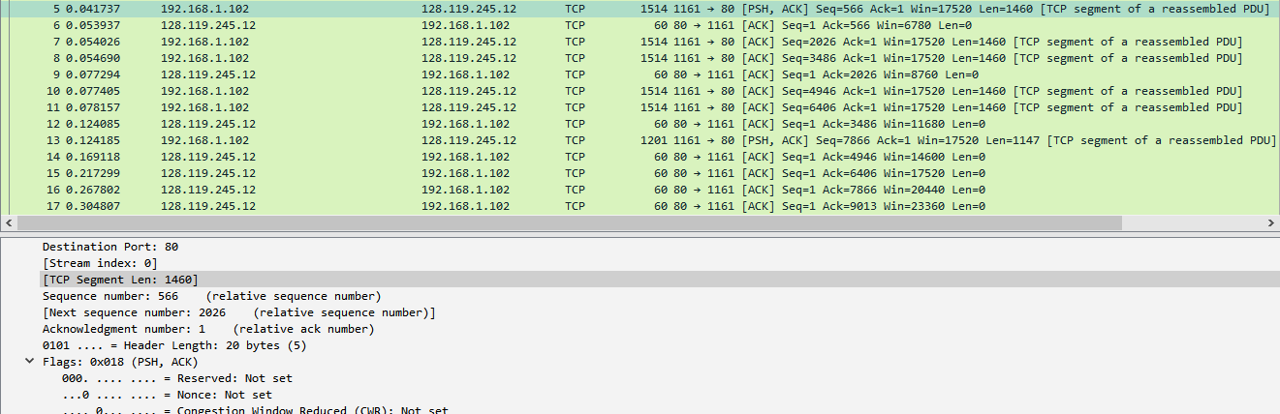

(No. 5)

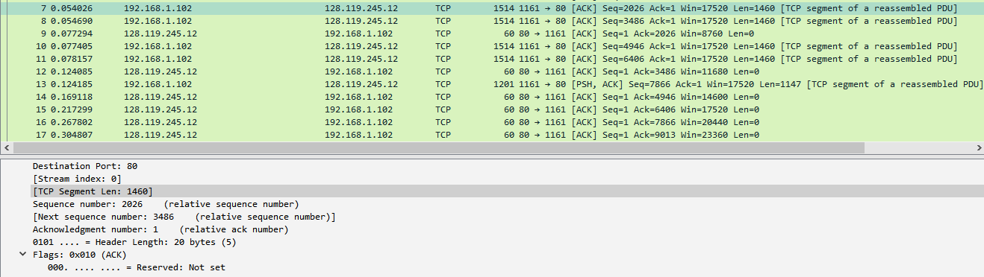

(No 7)

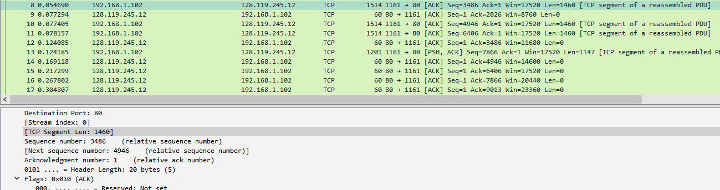

(No 8)

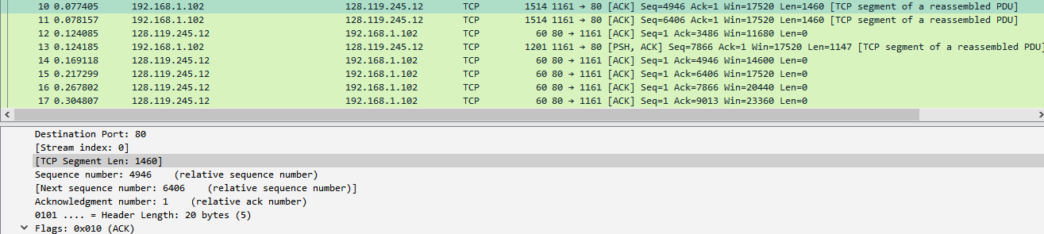

(No 10)

1. Segment 1: 565 bytes

All other: 1460 bytes

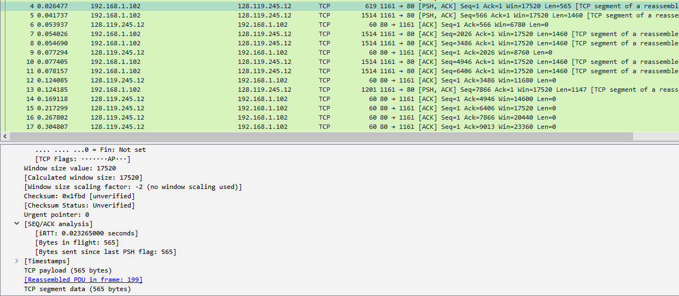

(No 4)

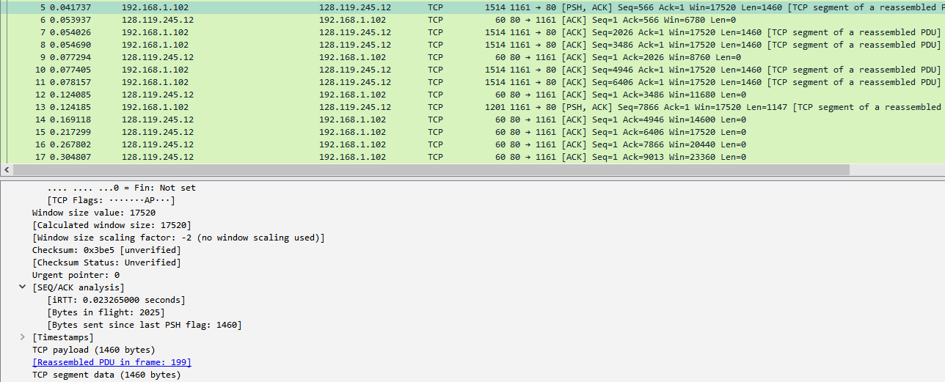

(No 5)

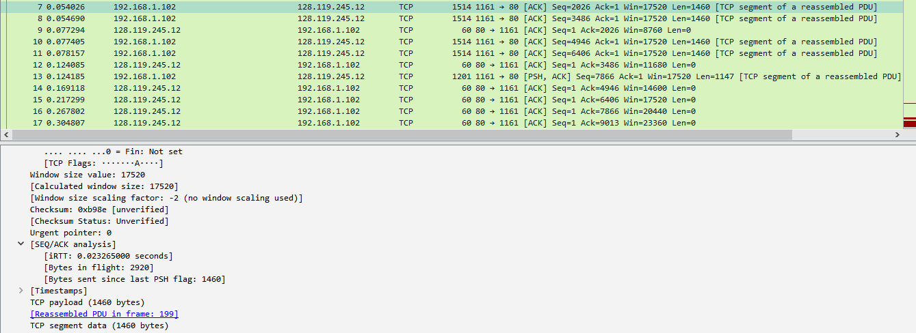

(No 7)

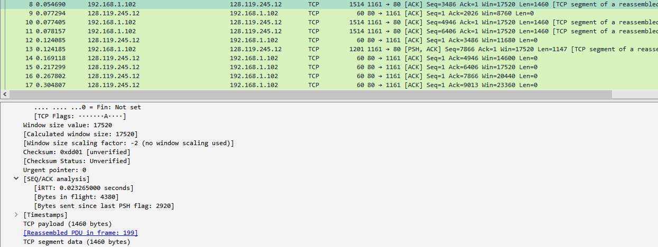

(No 8)

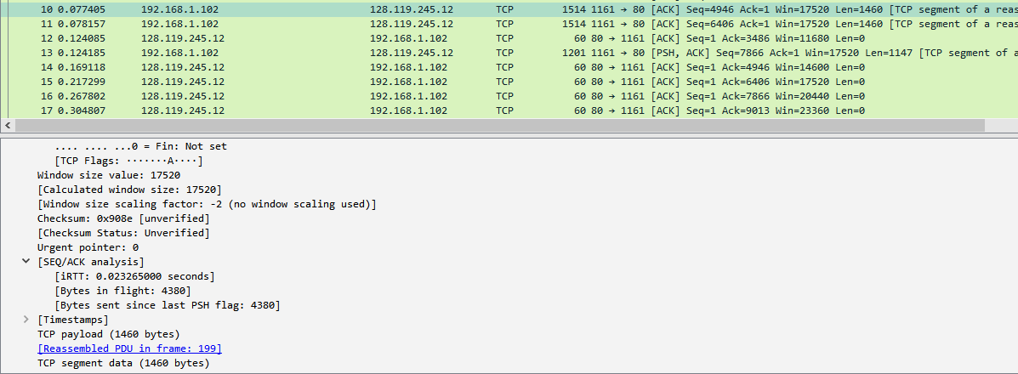

(No 10)